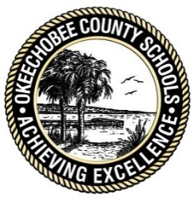
Okeechobee Public Schools

School Advisory Council/PTO
School: Yearling Middle School
Date: May 20th 2019 Time: 4:00- 4:45

- Welcome

- Minutes

- Academic and Discipline Data

- Dress Code

- Vision and Mission Statement for 2019-2020

- YMS Academic Strategy for Next year

- Open Forum and Discussion

- Announcements

- Next Meeting

- Adjournment

